OpenCable™
RemoteService Playback
Work in Progress
Notice
This document is an effort for the benefit of the OpenCable Team. Neither CableLabs, nor any other entity participating in the creation of this document, is responsible for any liability of any nature whatsoever resulting from or arising out of use or reliance upon this document by any party. This document is furnished on an AS-IS basis and neither CableLabs, nor other participating entity, provides any representation or warranty, express or implied, regarding its accuracy, completeness, or fitness for a particular purpose. Distribution of this document is restricted to internal CableLabs personnel.
© Copyright 2008 Cable Television Laboratories, Inc.
All rights reserved.
Version History

Version Number | Date | Contributor | Description
V1.0 | 12/11/2008 | K. Mastranunzio | Initial release

Contents
1 Introduction 1
2 Sequence Diagrams 2
2.1 Sequence Diagram – Application calls ServiceContext.select(RemoteService) - Renderer 2
2.2 Sequence Diagram – Application calls ServiceContext.select(RemoteService) – Server 3
3
2.3 Sequence Diagram – RemoteService Playback – setRate() – Renderer. 4
4
2.4 Sequence Diagram – RemoteService Playback – setRate() - Server 5
3 HTTP Request Header fields 6
4 CONTENT TYPE TO MIME TYPE TRANSLATION 7
5 MPEOS API 8
5.1 Home Networking Streaming API 8
5.1.1 mpeos_hnRemoteStreamServerStart 8
5.1.2 mpeos_hnRemoteStreamGetClientSessionInfo 9
5.1.3 mpeos_hnRemoteStreamClientStart 10
5.1.4 mpeos_hnRemoteStreamGetClientSessionInfo 11
5.1.5 mpeos_hnRemoteStreamGetServerInfo 12
5.1.6 13
5.1.7 mpeos_hnRemoteStreamServerStop 13
5.1.8 mpeos_hnRemoteStreamClientStop 14
5.1.9 mpeos_hnInit 15
5.1.10 mpeos_hnShutdown 16
5.1.11 mpeos_hnRemoteStreamRegisterQueueForStreamingEvents 16
5.1.12 mpeos_hnRemoteStreamUnRegisterQueue 17
5.2 Media API Changes 18
5.2.1 mpeos_MediaPlaybackChangePids 18
5.2.2 mpeos_MediaPlaybackGetPlayRates 20
5.2.3 mpeos_MediaPlaybackSetRate 21
5.2.4 mpeos_MediaPlaybackGetRate 22
5.2.5 mpeos_MediaPlaybackSetTime 23
5.2.6 mpeos_MediaPlaybackGetTime 24
5.2.7 mpeos_MediaPlaybackStop 25
5.2.8 mpeos_MediaPlaybackStart 26
5.3 Data Types and Structures 28
5.4 Events 28
6 Class Diagrams 29
Figures

Tables
Table 1 - Document Text Conventions Error! Bookmark not defined.

Introduction
The purpose of this document is describe the architectural details of how a device that implements OCAP and the OCAP Home Networking Extension will stream and render media across the home network.
The streaming subsystem will be broken into several components. The components will consist of JMF media handling on the client or requesting device, a home networking streaming manager on the client and server devices.s

Sequence Diagrams

Sequence Diagram – Application calls ServiceContext.select(RemoteService) - Renderer
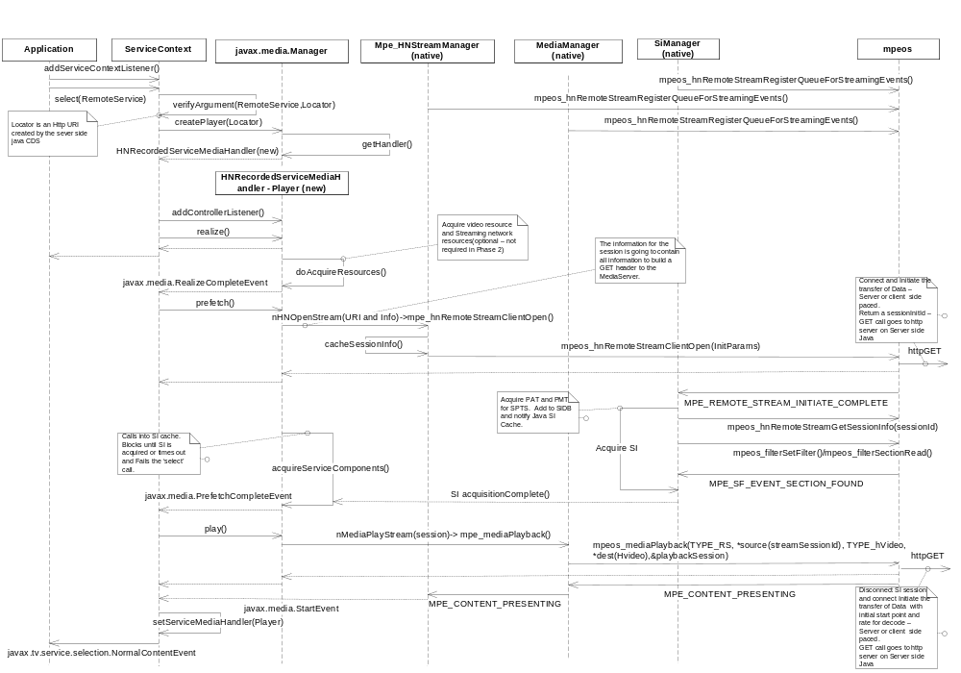

Sequence Diagram – Application calls ServiceContext.select(RemoteService) – Server

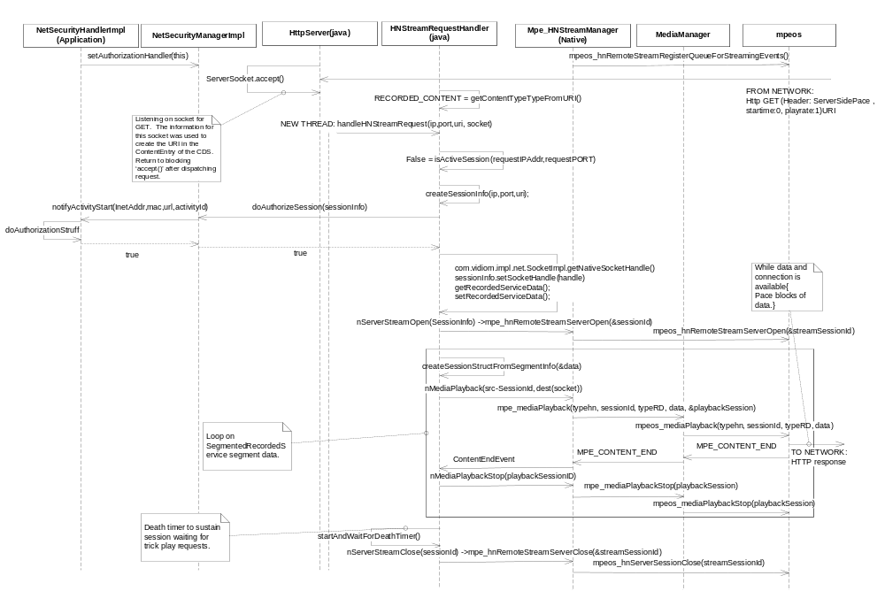

Sequence Diagram – RemoteService Playback – setRate() – Renderer.

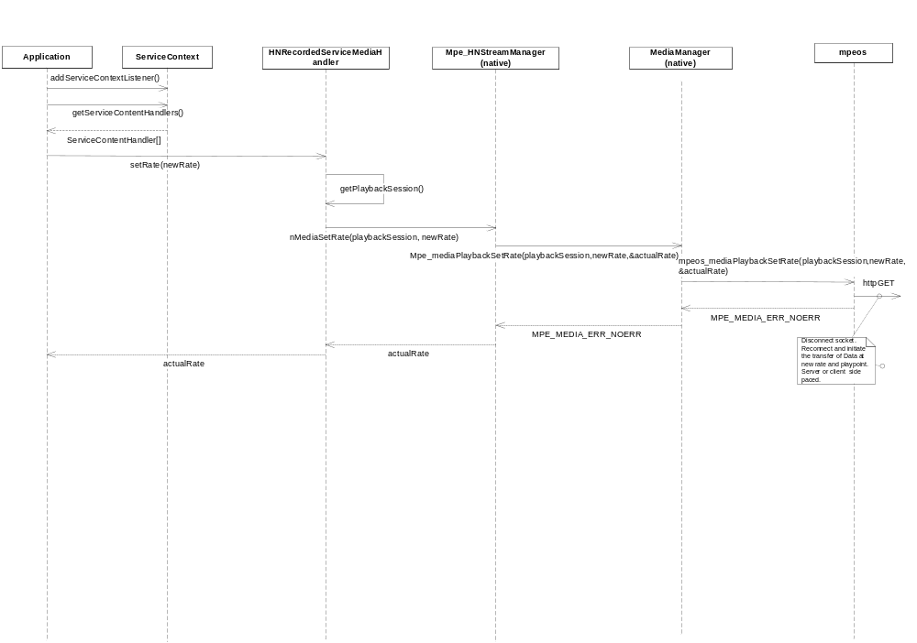

Sequence Diagram – RemoteService Playback – setRate() - Server
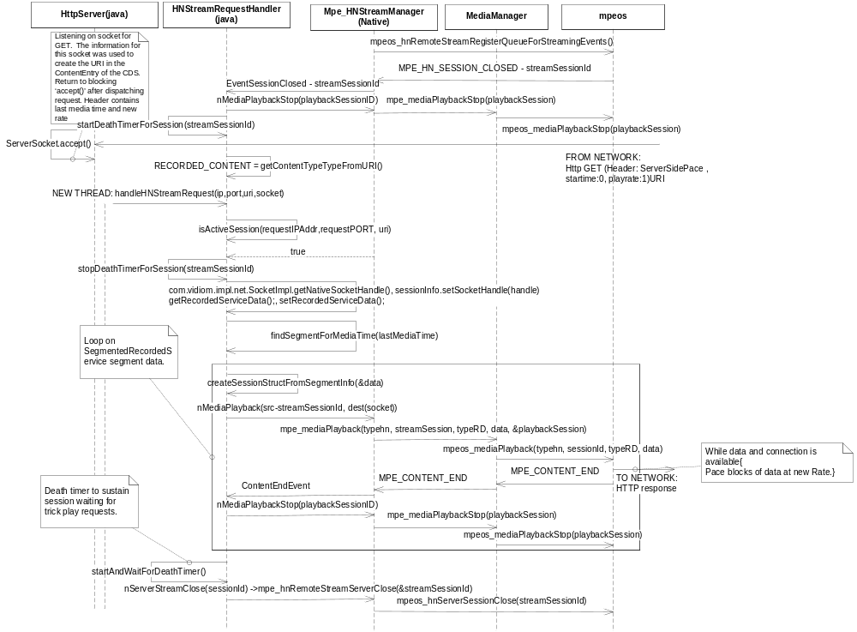

HTTP Request Header fields
The following header fields MAY be present in the request and response messaging during remote service streaming, therefore these fields will be represented in the mpeos data structures using to initiate the streaming to the remote device.
MaxTrickModeBandwidth | Uint32 | Optional
CurrentDecodePTS | Uint32 | Optional
ChunkEncodingMode | Enum | Required | GOP,Frame,Other
MaxGOPsPerChunk | Uint32 | Required
MaxFramesPerGOP | Uint32 | Optional
ServerSidePacedStreaming | Boolean | Optional | Default is no pacing
FrameTypesInTrickMode | Enum | Required | I,IP,ALL
FrameRateInTrickMode |  | Required
PresentationTimeStamps | Enum | Optional | startPTS,endPTS
AVStreamParameter |  | Optional
TimeSeekRange.dlna.org |  | Required | DLNA 7.4.40
PlaySpeed.dlna.org | Float | Required | Not > 1.5 * Normal

CONTENT TYPE TO MIME TYPE TRANSLATION
Media Type | OCAPHN | DLNA ProfileId | MimeType | Transfer
Image | JPG | JPEG_SM max resolution 640 x 480 | image/jpeg | Buffered Copy
Image | JPG | JPEG_MED | image/jpeg | Buffered Copy
Image | JPG | JPEG_LRG | image/jpeg | Buffered Copy
Image | JPG | JPEG_TN | image/jpeg | Buffered Copy
Image | JPG | JPEG_SM_ICO | image/jpeg | Buffered Copy
Image | JPG | JPEG_LRG_ICO | image/jpeg | Buffered Copy
Image | PNG | PNG_TN | image/png | Buffered Copy
Image | PNG | PNG_SM_ICO | image/png | Buffered Copy
Image | PNG | PNG_LRG_ICO | image/png | Buffered Copy
Image | PNG | PNG_LRG | image/png | Buffered Copy
Video | MPEG-2 TS | MPEG1 | video/mpeg | Streaming
Video | MPEG-2 TS | MPEG_PS_NTSC ( MPEG-2 PS) | video/mpeg | Streaming
Video | MPEG-2 TS | MPEG_PS_NTSC_XAC3 | video/mpeg | Streaming
Video | MPEG-2 TS | MPEG_TS_SD_NA_ISO | video/mpeg | Streaming
Video | MPEG-2 TS | MPEG_TS_SD_NA_XAC3_ISO | video/vnd.dlna. mpeg-tts | Streaming
Video | MPEG-2 TS | MPEG_TS_HD_NA_ISO | video/mpeg | Streaming
Video | MPEG-2 TS | MPEG_TS _SD_NA_T | video/vnd.dlna. mpeg-tts | Streaming
Video | MPEG-2 TS | MPEG_TS _HD_NA_T | video/vnd.dlna. mpeg-tts | Streaming
Video | MPEG-2 TS | MPEG_TS_HD_NA_XAC3_ISO | video/mpeg | Streaming
Video | MPEG-2 TS | AVC_TS_MP_SD_MPEG1_L3_ISO | video/mpeg | Streaming
Video | MPEG-2 TS | AVC_TS_MP_SD_AAC_MULT5_ISO | video/mpeg | Streaming
Video | MPEG-2 TS | AVC_TS_MP_SD_AC3_ISO | video/mpeg | Streaming
Video | MPEG-2 TS | AVC_TS_MP_HD_MPEG1_L3_ISO | video/mpeg | Streaming
Video | MPEG-2 TS | AVC_TS_MP_HD_AAC_MULT5_ISO | video/mpeg | Streaming
Video | MPEG-2 TS | AVC_TS_MP_HD_AC3_ISO | video/mpeg | Streaming
Monomedia Audio | MPEG-1 layer 1, 2 & 3; Dolby AC-3(What???) | LPCM | audio/L16 | Buffered Copy
Broadcast Streaming Audio | Dolby AC-3 | LPCM | audio/L16 | Streaming
Broadcast Streaming Audio | Dolby AC-3 | AC3 | audio/vnd.dolby.dd-raw | Streaming
Broadcast Streaming Audio | Dolby AC-3 | MP3 | audio/mpeg | Streaming
Broadcast Streaming Audio | Dolby AC-3 | MP3X | audio/mpeg | Streaming
Broadcast Streaming Audio | Dolby AC-3 | AAC_ADTS | audio/vnd.dlna.adts | Streaming
Broadcast Streaming Audio | Dolby AC-3 | AAC_ADTS_320 | audio/vnd.dlna.adts | Streaming
Broadcast Streaming Audio | Dolby AC-3 | AAC_ISO | audio/mp4 or audio/3gpp | Streaming
Broadcast Streaming Audio | Dolby AC-3 | AAC_ISO_320 | audio/mp4 or audio/3gpp | Streaming
Broadcast Streaming Audio | Dolby AC-3 | AAC_LTP_ISO | audio/mp4, audio/3gpp, or audio/vnd.dlna.adts | Streaming
Broadcast Streaming Audio | Dolby AC-3 | AAC_LTP_MULT7_ISO | audio/mp4, audio/3gpp, or audio/vnd.dlna.adts | Streaming
Broadcast Streaming Audio | Dolby AC-3 | AAC_MULT5_ADTS | audio/vnd.dlna.adts | Streaming
Broadcast Streaming Audio | Dolby AC-3 | AAC_MULT5_ISO | audio/mp4 or audio/3gpp | Streaming

MPEOS API

Home Networking Streaming API

mpeos_hnRemoteStreamStart
syntax mpe_Error mpeos_hnRemoteStreamStart (
mpe_HNRemoteStreamRequestParams * startRequest,
mpe_EventQueue queueId ,
void * act,
mpe_RemoteStreamSession * streamingSession);

parameter(s) startRequest is an input pointer to the start request parameters.
mpe_RemoteStreamStartRequestParams are defined in the
mpe_RemoteStreamStartRequestParams section.
queueId identifies the queue in which to send the stream start events
associated with this streaming request. mpe_EventQueue is
described in the mpe_EventQueue section. Currently, the
following events are supported:
streamingSession

NOTE: If an error is returned, no future events are delivered.
MPE_REMOTESTREAM_EVENT_SHUTDOWN
Indicates no further events can be sent to the queue.
MPE_REMOTESTREAM_START_ABORT
specifies either a start parameter change or an
asynchronous failure occurred during or after start.
MPE_ REMOTESTREAM_START_COMPLETE
specifies the start request is complete.
MPE_ REMOTESTREAM_START_FAIL
specifies the start request did not complete because the
streaming was unable to start for any reason.
MPE_ REMOTESTREAM_START_REQUEST
specifies a streaming start has been requested and that request
is being processed but is waiting for authorization.
act is an input pointer to an ACT. When the asynchronous
events are sent to the event queue specified in queueId (via
mpeos_eventQueueSend()), the event should pass this act
pointer in the optionalEventData2 parameter. The pointer to
act should not be sent to those event queues which are
registered via mpeos_remoteStreamRegisterQueueForStreamEvents().
value returned If the call is successful, mpeos_hnRemoteStreamStart() should return MPE_SUCCESS.
Otherwise, it should return one of the following error codes:
MPE_EINVAL indicates at least one input parameter to the function has an
invalid value.
MPE_ERROR_REMOTE_STREAM_BAD_START_REQUEST
specifies the tune request failed.
MPE_ERROR_REMOTE_STREAM_OS
specifies an operating system error.
description mpeos_hnRemoteStreamStart() should start the asynchronous streaming operation. An
error code is synchronously returned to the caller to indicate a preliminary
state of resource allocation.
related function(s)
mpeos_eventQueueNew
mpeos_hnRemoteStreamClientStop

mpeos_hnRemoteStreamGetSessionInfo
gets the current home networking client stream session information.
syntax mpe_Error mpeos_hnRemoteStreamGetSessionInfo(
uint32_t sessionId,
mpe_hnRemoteStreamRequestParams * sessionParams );
parameter(s) sessionId specifies the sessionId.
sessionParams is an output pointer to the session information.
mpe_hnRemoteStreamRequestParams is described in the
mpe_hnRemoteStreamRequestParams section.
value returned If the call is successful, mpeos_hnRemoteStreamGetSessionInfo() should return
MPE_SUCCESS. Otherwise, it should return one of the following error codes:
MPE_EINVAL indicates sessionId has an invalid value.
MPE_ERROR_REMOTE_STREAM_OS
specifies an operating system error.
description mpeos_ hnRemoteStreamGetSessionInfo () should return the current session parameters
for the target session.

mpeos_hnRemoteStreamStop
syntax mpe_Error mpeos_hnRemoteStreamStop(mpe_RemoteStreamSession session );

parameter(s) session specifies the streaming session.
value returned If the call is successful, mpeos_hnRemoteStreamStop() should return MPE_SUCCESS.
Otherwise, it should return one of the following error codes:
MPE_EINVAL indicates session has an invalid value.
MPE_ERROR_REMOTESTREAM_RESOURCE_NOT_ACTIVE
specifies the resource is not available.
MPE_ERROR_OS
specifies an operating system error.
description mpeos_hnRemoteStreamStop() should stop streaming of media to the remote endpoint.
mpeos_hnRemoteStreamStop() sends the MPE_HN_EVENT_ STOP event to the queue.
related function(s) mpeos_remoteStreamStart

mpeos_hnInit
syntax mpe_Error mpeos_hnRemoteStreamInit( void );
parameter(s) none
value returned If the call is successful, mpeos_hnRemoteStreamInit() should return MPE_SUCCESS.
Otherwise, it should return the following error code:
MPE_ENOMEM indicates the function failed due to insufficient memory
resources.
description mpeos_hnRemoteStreamInit() should perform platform-specific initialization support
for the remote streaming API.
related function(s) mpeos_hnRemoteStreamShutdown

mpeos_hnShutdown
syntax mpe_error mpeos_hnRemoteStreamShutdown( void );
parameter(s) none
value returned If the call is successful, mpeos_hnRemoteStreamShutdown () should return
MPE_SUCCESS. Otherwise, it should return the following error code:
MPE_ERROR_HN_OS
specifies an operating system error.
description mpeos_hnRemoteStreamShutdown() should send shutdown events to the remote stream and
decoder. mpeos_hnShutdown() releases any remote streaming-related resources
back to the operating system. mpeos_hnRemoteStreamShutdown() sends the
MPE_EVENT_SHUTDOWN event to the queue identifier of mpeos_hnRemoteStreamClientStart() o, mpeos_hnRemoteStreamServerStart() and mpeos_MediaPlaybackStart().
related function(s) mpeos_hnRemoteStreamInit

mpeos_hnRemoteStreamRegisterQueueForStreamingEvents
registers an event queue.
syntax mpe_Error mpeos_hnRemoteStreamRegisterQueueForStreamingEvents(
mpe_EventQueue queueId );
parameter(s) queueId identifies an additional queue that receives streaming
events that result from any mpeos_hnRemoteStreamStart() or
mpeos_hnRemoteStreamOpen() call. mpe_EventQueue is described in the
mpe_EventQueue section. Currently, the following events
are supported:
NOTE: If an error is returned, no future events are delivered.
MPE_STREAM_INITIATE_ABORT
specifies either a streaming parameter change or an
asynchronous failure occurred during or after tuning.
MPE_STREAM_ INITIATE _COMPLETE
specifies the stream open is complete.
MPE_STREAM_ INITIATE _FAIL
specifies the stream open did not complete because the
tuner was unable to tune for any reason.
MPE_STREAM_ INITIATE_STARTED
specifies a stream initiate was requested and that request needs to
be processed.
MPE_STREAM_CLOSED
specifies a stream open was closed .
value returned If the call is successful, mpeos_hnRemoteStreamRegisterQueueForStreamingEvents()
should return MPE_SUCCESS. Otherwise, it should return one of the
following error codes:
MPE_EINVAL indicates queueId has an invalid value.
MPE_ENOMEM indicates the function failed due to insufficient memory
resources.
description mpeos_hnRemoteStreamRegisterQueueForStreamingEvents() should register an MPE
event queue for receiving all home networking stream events.
related function(s) mpeos_hnRemoteStreamOpen
mpeos_hnRemoteStreamStart,
mpeos_hnRemoteStreamUnregisterQueue

mpeos_hnRemoteStreamUnRegisterQueue

syntax mpe_Error mpeos_hnRemoteStreamUnregisterQueue( mpe_EventQueue queueId );
parameter(s) queueId identifies the queue to unregister. mpe_EventQueue is
described in the mpe_EventQueue section.
value returned If the call is successful, mpeos_ hnRemoteStreamUnregisterQueue () should return
MPE_SUCCESS. Otherwise, it should return the following error code:
MPE_EINVAL indicates queueId has an invalid value.
description mpeos_ hnRemoteStreamUnregisterQueue () should unregister an MPE event queue
from receiving streaming events. Streaming events
are defined in the Events section.
related function(s) mpeos_hnRemoteStreamInitiate
mpeos_ hnRemoteStreamRegisterQueueForStreamingEvents
mpeos_ hnRemoteStreamStart

Media API Changes

mpeos_MediaPlaybackChangePids
syntax mpe_Error mpeos_MediaPlaybackChangePids(
mpe_MediaPlaybackSession playback,
int32 num,
int32 * PIDs,
int32 pcrPID );
parameter(s) playback specifies the handle to the playback. Pid[] is an array or pid.
num is the number of entries in the pid[].
pcrPid is the pcr pid value.
value returned NOTE: If an error is returned, no future events are delivered.
Currently, the following events are supported:
MPE_EVENT_SHUTDOWN
indicates no further events can be sent to the queue.
MPE_ACTIVE_FORMAT_CHANGED
indicates the AFD type of input video, either letter
boxed or pillar boxed.
MPE_ASPECT_RATIO_CHANGED
indicates the aspect ratio changed.
MPE_DFC_CHANGED
indicates the current DFC changed.
MPE_FAILURE_NO_DATA
indicates the pid change request has failed because data
is no longer being delivered (for example, the remote streaming device has been disabled
or removed).
MPE_FAILURE_UNKNOWN
indicates the pid change request has failed due to an
unknown reason.
act is an input pointer to an Asynchronous Completion Token
(ACT). When the asynchronous events are sent to the
event queue specified in queueId (via
mpeos_eventQueueSend()), the event should pass this act
pointer in the optionalEventData2 parameter.
session is an output pointer to store the new decode session. If the
function fails, the pointer is set to point to NULL.
mpe_MediaPlaybackSession is described in the
mpe_MediaPlaybackSession section.
value returned If the call is successful, mpeos_MediaPlaybackChangePids() should return MPE_SUCCESS.
Otherwise, it should return one of the following error codes:
MPE_EINVAL indicates at least one input parameter to the function has an
invalid value.
MPE_ERROR_MEDIA_INVALID_ID
specifies an invalid tuner identifier.
MPE_ERROR_MEDIA_RESOURCE_NOT_ACTIVE
specifies the resource is not available.
description mpeos_MediaPlaybackChangePids() should start presenting the new media streams specified
by the PIDs. A successful call to mpeos_MediaPlaybackStart() must be made before
calling mpeos_MediaPlaybackChangePids(). Subsequent calls to mpeos_MediaPlaybackChangePids()
that include PIDs which are already presenting, must continue to present
those streams without interruption.
related function(s)
mpeos_mediaPlaybackStop
mpeos_mediaPlaybackStart

mpeos_MediaPlaybackGetPlayRates
syntax mpe_Error mpeos_MediaPlaybackGetPlayRates(
float ** playScales,
uint32_t * num );
parameter(s)
playScales is an output pointer to the play scales array (floating-point
values).
num is an output pointer to the number of entries in the play
scales array.
value returned If the call is successful, mpeos_MediaGetPlayRates () should return
MPE_ERR_NOERR. Otherwise, it should return one of the following error
codes:
MPE_MEDIA_ERR_INVALID_PARAM
indicates an invalid parameter.
MPE_MEDIA_ERR_OS_FAILURE
indicates an error occurred at the operating-system level.
MPE_MEDIA_ERR_DEVICE_ERR
indicates a hardware device error.
description mpeos_MediaGetPlayRates () should get all the play scales supported for the
platform (for example, -2.0, -.25, .25, 2.0, etc.).
related function(s) none

mpeos_MediaPlaybackSetRate
syntax mpe_Error mpeos_MediaPlaybackSetRate(
mpe_MediaPlaybackSession playback,
float mode,
float * actualMode );
parameter(s) playback specifies the handle to the playback session. This handle is used to
control rate and media positions. playback is returned
from a previous call to mpeos_MediaPlaybackStart(). mpe_MediaPlaybackStart is described in
the mpe_MediaPlayback section.
mode specifies the desired trick mode. mode can be returned from
a previous call to mpeos_MediaGetPlayRates(). Rate mode
values vary based on the operating system.
actualMode is an output pointer to the actual mode set by the playback
system.
value returned If the call is successful, mpeos_MediaPlaybackSetRate() should return
MPE_MEDIA_ERR_NOERR. Otherwise, it should return one of the following error
codes:
MPE_MEDIA_ERR_INVALID_PARAM
indicates an invalid parameter.
MPE_MEDIA_ERR_OS_FAILURE
indicates an error occurred at the operating-system level.
description mpeos_mediaPlaybackSetRate () should set the playback speed and direction.
Rate mode should determines the playback speed and direction, for
example, 0.5 specifies forward at half the normal speed and -2.0 specifies
rewind at twice the normal speed. Rate mode may not be supported by all
operating systems. If rate mode is not supported, the closest supported
rate mode should be set and returned.
related function(s) mpeos_MediaPlaybackGetPlayRates

mpeos_MediaPlaybackGetRate

syntax mpe_Error mpeos_MediaPlaybackGetRate(
mpe_MediaPlaybackSession playback,
float * rate );
parameter(s) playback specifies the handle to the playback. playback is returned by
a previous call to mpeos_MediaPlaybackStart(). mpeos_MediaPlaybackStart is described in
the mpeos_MediaPlaybackStart section.
rate is an output pointer to the current playback rate. Playback rate
values vary based on the operating system. rate is returned
by a previous call to mpeos_MediaPlaybackSetRate().
value returned If the call is successful, mpeos_MediaPlaybackGetRate() should return
MPE_DVR_ERR_NOERR. Otherwise, it should return the following error code:
MPE_DVR_ERR_INVALID_PARAM
indicates an invalid parameter.
description mpeos_MediaPlaybackGetRate() should get the playback rate associated
with a specified playback session.
related function(s) mpeos_MediaPlaybackSetRate

mpeos_MediaPlaybackSetTime
syntax mpe_Error mpeos_mediaPlaybackSetTime(
mpe_MediaPlaybackSession playback,
int64 mediaTime );
parameter(s) playback specifies the handle to the playback. This handle is used to
control trick play and media positions. playback is returned
by a previous call to mpeos_MediaPlaybackStart(). mpe_MediaPlaybackStart is described in
the mpe_MediaPlaybackStart section.
mediaTime specifies the current position in nanoseconds in which to
jump.
value returned If the call is successful, mpeos_MediaPlaybackSetTime() should return
MPE_MEDIA_ERR_NOERR. Otherwise, it should return one of the following error
codes:
MPE_MEDIA_ERR_INVALID_PARAM
indicates an invalid parameter.
MPE_MEDIA_ERR_OS_FAILURE
indicates an error occurred at the operating-system level.
description mpeos_MediaPlaybackSetTime() should move the playback position to a
specified time.
related function(s) mpeos_mediaPlaybackSetRate, mpeos_mediaPlaybackGetRate

mpeos_MediaPlaybackGetTime

syntax mpe_Error mpeos_MediaPlaybackGetTime(
mpe_MediaPlaybackSession playback,
int64 * mediaTime );
parameter(s) playback specifies the handle to the playback. This handle is used to
control rate and media positions. playback is returned
by a previous call to mpeos_MediaPlaybackStart(). mpe_MediaPlaybackStart is described in
the mpe_MediaPlaybackStart section.
mediaTime is an output pointer to the current media time in
nanoseconds. mediaTime is returned by a previous call to
mpeos_MediaPlaybackSetTime().
value returned If the call is successful, mpeos_MediaPlaybackGetTime() should return
MPE_MEDIA_ERR_NOERR. Otherwise, it should return one of the following error
codes:
MPE_MEDIA_ERR_INVALID_PARAM
indicates an invalid parameter.
MPE_MEDIA_ERR_OS_FAILURE
indicates an error occurred at the operating-system level.
description mpeos_mediaPlaybackGetTime() should get the current playback time. This
time should represent current position in the playback.
related function(s) mpeos_mediaPlaybackSetTime

mpeos_MediaPlaybackStop
syntax mpe_Error mpeos_MediaPlaybackStop( mpe_MediaPlaybackSession session );

parameter(s) session specifies the streaming session.
value returned If the call is successful, mpeos_MediaPlaybackStop() should return MPE_SUCCESS.
Otherwise, it should return one of the following error codes:
MPE_EINVAL indicates session has an invalid value.
MPE_ERROR_MEDIA_RESOURCE_NOT_ACTIVE
specifies the resource is not available.
MPE_ERROR_MEDIA_OS
specifies an operating system error.
description mpeos_MediaPlaybackStop() should stop decoding and presenting the media.
mpeos_MediaPlaybackStop () sends the MPE_EVENT_SHUTDOWN event to the queue
identifier of mpeos_MediaPlaybackStop().
related function(s) mpeos_MediaPlaybackStart

mpeos_MediaPlaybackStart

syntax mpe_Error mpeos_MediaPlaybackStart (
Mpe_StreamSource_Type, void * decodeSource,
Mpe_StreamSink_Type, void * decodeDestination
mpe_EventQueue queueId ,
void * act,
mpe_MediaPlaybackSession * session ) ;

parameter(s) decodeSource is an input pointer to the decode request parameters.
mpe_MediaPlaybackRequestParams is described in the
mpe_MediaPlaybackRequestParams section.
queueId identifies the queue in which to send the decode events
associated with this decode request.
mpe_EventQueue is
described in the mpe_EventQueue section.
If one or more of the requested streams cannot be
presented, the reason for the stream failure is indicated by
sending a stream event for each such stream followed by a
MPE_CONTENT_PRESENTING event.
mpeos_MediaPlaybackStart() continues to monitor the failed streams until either
mpeos_MediaPlaybackStop() is called.

NOTE: If an error is returned, no future events are delivered.
Currently, the following events are supported:
MPE_EVENT_SHUTDOWN
indicates no further events can be sent to the queue.
MPE_ACTIVE_FORMAT_CHANGED
indicates the AFD type of input video, either letter
boxed or pillar boxed.
MPE_ASPECT_RATIO_CHANGED
indicates the aspect ratio changed.
MPE_DFC_CHANGED
indicates the current DFC changed.
During a full decoder stop all decoding stops and does not
restart until another call to mpeos_remoteStreamDecode() is made.
A full decoder stop is indicated by sending one of the
following events:
MPE_FAILURE_NO_DATA
indicates the decode request has failed because data
is no longer being delivered (for example, the remote streaming device has been disabled
or removed).
MPE_FAILURE_UNKNOWN
indicates the decode request has failed due to an
unknown reason.
act is an input pointer to an Asynchronous Completion Token
(ACT). When the asynchronous events are sent to the
event queue specified in queueId (via
mpeos_eventQueueSend()), the event should pass this act
pointer in the optionalEventData2 parameter.
session is an output pointer to store the new decode session. If the
function fails, the pointer is set to point to NULL.
mpe_MediaPlaybackSession is described in the
mpe_MediaPlaybackSession section.
value returned If the call is successful, mpeos_MediaPlaybackStart() should return MPE_SUCCESS.
Otherwise, it should return one of the following error codes:
MPE_EINVAL indicates at least one input parameter to the function has an
invalid value.
MPE_ERROR _INVALID_ID
specifies an invalid tuner identifier.
MPE_ERROR_ RESOURCE_NOT_ACTIVE
specifies the resource is not available.
description mpeos_MediaPlaybackStart() should start presenting the media streams specified
by the PIDs. A successful call to mpeos_hnRemoteStreamClientStart() or mpeos_hnRemoteStreamServerStart() must be made before calling mpeos_MediaPlaybackStart(). Subsequent calls to mpeos_MediaPlaybackStart()
that include PIDs which are already presenting, must continue to present
those streams without interruption.
related function(s)
mpeos_MediaPlaybackStop

Data Types and Structures
Media Playback Session Handle
typedef struct _mpe_MediaPlaybackSessionH { int unused1; } *mpe_MediaPlaybackSession;
typedef struct _mpe_HNStreamSessionH { int unused1; } *mpe_HNStreamSession;

#define MPE_MEDIA_SOURCE_UNDEFINED 0x00;
#define MPE_MEDIA_SOURCE_TUNER 0x01;
#define MPE_MEDIA_SOURCE_DRIPFEED 0x02;
#define MPE_MEDIA_SOURCE_HN 0x03;
#define MPE_MEDIA_SOURCE_DVR_RECORDING 0x04;
#define MPE_MEDIA_SOURCE_DVR_TSB 0x05;

#define MPE_MEDIA_DEST_UNDEFINED 0x00;
#define MPE_MEDIA_DEST_HVIDEODEVICE 0x01;
#define MPE_MEDIA_DEST_HN 0x02;
#define MPE_MEDIA_DEST_DVR_RECORDING 0x03;
#define MPE_MEDIA_DEST_DVR_TSB 0x04;

/*
** HN Specific Types
*/
typedef enum _mpe_HNStreamContentType{
MPE_CONTENT_TYPE_VIDEO_VND_DLNA_MPEG_TTS,
MPE_CONTENT_TYPE_VIDEO_MPEG,
MPE_CONTENT_TYPE_AUDIO_L16,
MPE_CONTENT_TYPE_AUDIO_VND_DOLBY_DD_RAW,
MPE_CONTENT_TYPE_AUDIO_VND_DLNA_ADTS,
MPE_CONTENT_TYPE_AUDIO_MP4,
MPE_CONTENT_TYPE_AUDIO_3GGP,
MPE_CONTENT_TYPE_AUDIO_MPEG,
} mpe_HNStreamContentType;

typedef enum _mpe_HNStreamProtocolType{
MPE_HN_PROTOCOL_TYPE_HTTP_V1_1
}mpe_HNStreamProtocolType;

typedef enum _mpe_HNStreamOpenRequestType{
MPE_MEDIA_MEDIA_PLAYER_HTTP,
MPE_MEDIA_MEDIA_SERVER_HTTP
} mpe_HNStreamOpenRequestType;

// mpe_HNStreamOpenRequestParams
typedef struct _mpe_HNStreamOpenRequestParams{
mpe_HNStreamOpenRequestType requestType;
void ** openParams; //mpe_HNStreamOpenParams openParams;
} mpe_HNStreamOpenRequestParams;

typedef struct _mpe_HNStreamURI{
uint8_t * scheme;
uint8_t * scheme_specific_part;
uint8_t * authority;
uint8_t * user-info;
uint8_t * host;
uint32_t port;
uint8_t * path;
uint8_t * query;
uint8_t * fragment;
} mpe_HNStreamURI;

typedef struct _mpe_HNStreamOpenParamsMediaPlayer_Http{
mpe_HNStreamURI uri;
mpe_HNStreamContentType content_type;
uint32_t intialRate;
uint32_t startTime;
} mpe_HNStreamOpenParamsMediaPlayer_Http;

typedef enum _mpe_HNHttpChunkEncodingMode{
MPE_HTTP_HEADER_CEM_GOP,
MPE_HTTP_HEADER_CEM_FRAME,
MPE_HTTP_HEADER_CEM_OTHER
}mpe_HNHttpChunkEncodingMode;

typedef enum _mpe_HNHttpHeaderFrameTypeInTrickMode{
MPE_ HTTP_HEADER_FRAME_TYPE_I,
MPE_ HTTP_HEADER_FRAME_TYPE_IP,
MPE_ HTTP_HEADER_FRAME_TYPE_ALL
} mpe_HNHttpHeaderFrameTypeInTrickMode;

typedef enum _mpe_HNHttpHeaderPresentationTimeStamps{
MPE_HTTP_HEADER_START_PTS,
MPE_HTTP_HEADER_END_PTS
} mpe_HNHttpHeaderPresentationTimeStamps;

typedef struct _mpe_HNHttpHeaderAVStreamParameters{
uint32_t videoPID;
uint32_t videoType;
uint32_t audioPID;
uint32_t audioType;
} mpe_HNHttpHeaderAVStreamParameters;

typedef struct _mpe_HNHttpHeaderInfo{
uint32_t maxTrickModeBandwidth;
uint32_t currentDecodePTS;
mpe_HNHttpChunkEncodingMode chunkEncodingMode;
uint32_t maxGOPsPerChunk;
uint32_t maxFramesPerGOP;
mpe_bool serverSidePacedStreaming;
mpe_HNFrameTypeInTrickMode frameTypesInTrickMode
uint32_t frameRateInTrickMode;
HNHttpHeaderPresentationTimeStamps presentationTimeStamp;
mpe_HNHttpHeaderAVStreamParameters AVStreamParameter;
uint32_t timeSeekRangeDlnaOrg;
uint32_t playSpeedDlnaOrg;
} mpe_HNHttpHeaderInfo;

typedef struct _mpe_HNStreamContentInfo{
uint32_t contentInfoSize;
uint8_t* contentInfo;
mpe_HNStreamContentType content_type;
} mpe_HNStreamContentInfo;

typedef struct _mpe_HNStreamOpenParamsMediaServerHttp{
mpeos_Socket socket;
mpe_HNStreamContentInfo contentInfo;
Mpe_HNHttpHeaderInfo headerInfo;
} mpe_HNStreamOpenParamsMediaServerHttp;

Events

Class Diagrams

